Special Educational Needs and Disabilities (SEND) Information Report
HOLY TRINITY & ST JOHN’S CE PRIMARY SCHOOL


Inclusion Team

SEND Governor:
Stacey Mitchell
Assistant Headteacher, Inclusion Lead & SENDCO – Donna McGuirk
SRP Lead Teacher & SENDCO - Recruitment is currently underway.
The report will be updated when the appointment is confirmed.
SENDCO assistant - Louise Sands
SEND Teacher – Beth Castle

Inclusion Team:
senadmin@htsj.school
Contact No. 01843 223237

Approved by: | Chair of Governors | Date: September 2026
Last reviewed on: | September 2026
Next review due by: | September 2027

Contents
1. What types of SEND does the school provide for? 4
2. Which staff will support my child? 5
3. What should I do if I think my child has SEND? 7
4. What happens if the school identifies a need? 8
5. How will the school measure my child’s progress? 9
6. How will I be involved in decisions made about my child’s education? 10
7. How will my child be involved in decisions made about their education? 11
8. How will the school adapt its teaching for my child? 12
9. How will the school evaluate whether the support in place is helping my child? 13
10. How will the school ensure my child has appropriate resources? 13
11. How will the school make sure my child is included in activities alongside pupils who don’t have SEND? 14
12. How does the school make sure the admissions process is fair for pupils with SEN or a disability? 15
13. How does the school support pupils with disabilities? 15
14. How will the school support my child’s mental health and emotional and social development? 16
15. What support is in place for looked-after and previously looked-after children with SEN? 16
16. What support will be available for my child as they transition between classes or settings or in preparing for adulthood? 17
17. What support is available for me and my family? (Local Offer) 18
18. What should I do if I have a complaint about my child’s SEND support? 19
19. Supporting Documents…………………………………………………………………………………………………………….19
20. Glossary 20

Dear parents and carers,
The aim of this Information Report is to explain how we implement our SEND policy. In other words, we want to show you how SEND support works in our school.
The report has been developed with consideration of the views and experiences of pupils, parents/carers, our staff and leadership team. We welcome feedback about our SEND provision and use this to review and improve our practice.
As educational professionals, we are all working towards the ultimate goal of growing independent young people as they prepare for adulthood. All provision and support we provide is working towards achieving the Kent Children and Young People (CYP) Outcomes Framework:
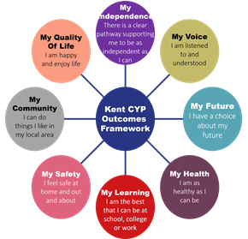

If you want to know more about our arrangements for SEND, read our SEND policy alongside this Information Report.
You can find our SEND policy on our website https://www.holytrinitymargate.co.uk/policies/

Note: If there are any terms we have used in this information report that you’re unsure of, you can look them up in the Glossary at the end of the report.

1. What types of SEND does the school provide for?
Our school provides for children with the following needs (as outlined in the SEND Code of Practice 2015):

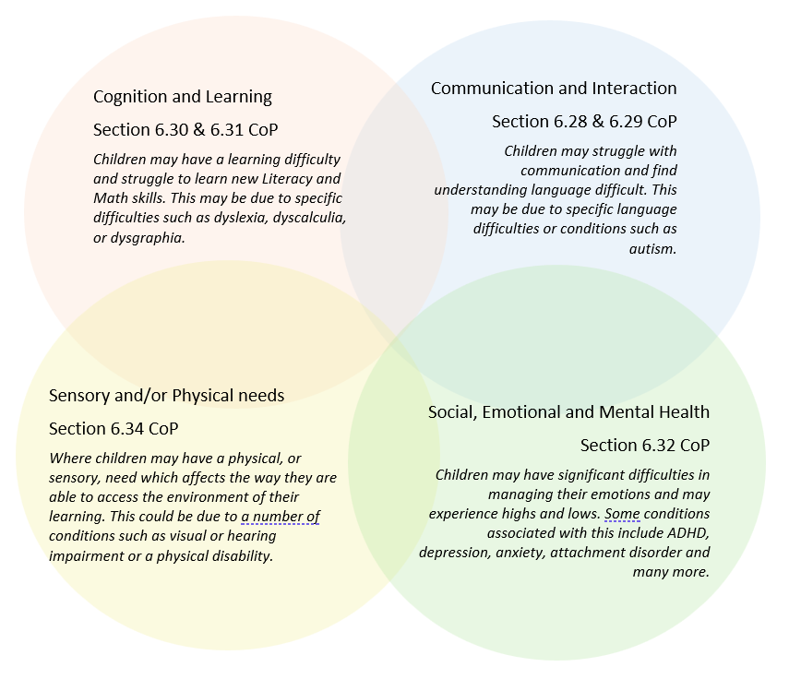
Often you will find that children’s needs overlap and are rarely confined to one area of need, which is why it is important to gain a holistic overview of your child.
More information about the Areas of Need can be found in the Special educational needs and disability code of practice: 0 to 25 years (link below).
SEND_Code_of_Practice_January_2015.pdf (publishing.service.gov.uk)


2. Which staff will support my child, and what are their key responsibilities?

At Holy Trinity & St John’s CE Primary School all staff are considered responsible for supporting the needs of children with SEND. Our staff are committed to regular, high-quality training to ensure that they have the knowledge and skills to better meet a wide range of needs.
Below outlines key staff who will be supporting your child. Please note that this list is not exhaustive.
Our Special Educational Needs and Disabilities Co-ordinator, or SENDCO
At Holy Trinity & St John’s CE Primary our Inclusion Lead and SENDCO is Donna McGuirk.
Donna McGuirk is a qualified teacher with over 24 years' experience of supporting children with their learning within educational settings. She is trained and experienced in all key areas of SEND and has over 8 years’ experience in the role of SENDCO, for 6 of these years in post at Holy Trinity & St John’s Primary School. She is a qualified THRIVE practitioner (early identification of emotional development needs in children and young people) and has experience of teaching across all phases within a primary school setting, from pre-school to key stage 2. In addition, Mrs McGuirk has completed her master's level NASENCO award, has completed SEND law training at levels 1, 2 and 3 through IPSEA. She holds a Bachelor of Arts Degree with First Class Honours in Childhood Studies, alongside post graduate certificates in Teaching and Learning. Mrs McGuirk leads the inclusion team (see below) and can be contacted via the school office on a Monday, Wednesday and Friday and on a Tuesday and Thursday morning.

Our Inclusion Team

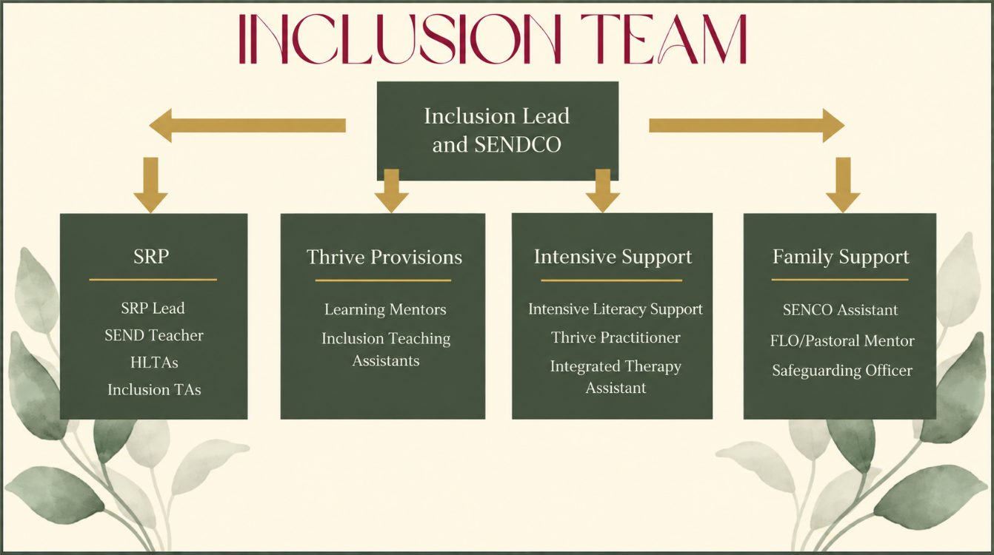

We are extremely proud of our Inclusion and SRP team, our Headteacher has been in education for over 20 years and is a qualified SENDCO and an Inclusion Champion for the Local Authority, therefore we know inclusion is at the centre of all we do.

Our Team:
Louise Sands has been working at Holy Trinity and St John's school since 2021 as the Family Liaison Officer and SENDco Assistant. She has over 25 years of experience working with children ranging from 0-16 years in various settings, including nurseries, an early intervention unit, primary and secondary schools. Mrs Sands is also a mum of a child with Special Educational Needs who attends specialist provision. She holds a Foundation degree in Childhood studies, NVQ level in Eary Years and Education and has completed the Thrive Practitioner and Family Thrive trainers’ courses. Mrs Sands has completed the Assistant SENDCO level 5 qualification as part of her new role. Mrs Sands is at school each day should you need to contact her.

Our Pastoral Mentor is Mrs Gilman. She supports children who have been bereaved, are worried about something, have issues with siblings etc.
She makes resources and social stories to support with individual needs to be used at home and school.
Over the 25 plus years Mrs Gilman has worked at HTSJ she has gained experience by working in all year groups as a teaching assistant before becoming a Pastoral mentor. She was also chair of the PTFA for about ten years. Mrs Gilman’s qualifications are quite numerous and varied which ensures she can offer a broad range of support to pupils, parents and colleagues. Her time often involves listening impartially and being a shoulder to lean on.
Mrs Gilman is available from 8.30 daily until 4pm, 3.30pm on Fridays.

Bethany Castle is a qualified SEND teacher and Thrive Practitioner with 10 years of experience working within schools and supporting children with a wide range of additional needs. Throughout her career, she has worked in a variety of roles across all broad areas of SEND, developing a strong understanding of how to support each child as an individual. She is passionate about creating nurturing, inclusive and engaging learning environments where children feel safe, valued and supported to be successful in their development and learning. She particularly enjoys using sensory, hands-on and child-centred approaches to make learning meaningful and accessible. She enjoys working collaboratively with children, families and colleagues to ensure the best possible outcomes for every child.
Ms Castle’s availability is Mondays, Thursdays and Fridays after school. If you would like to arrange a meeting, please speak to Beth at The Hive or contact the school office, and a suitable time can be arranged.

We are currently advertising for an SRP Lead Teacher and will update the report when they are in post.

Class/subject teachers
All our teachers receive in-house SEN training, and are supported by the SENDCO to meet the needs of children who have SEN.
Within the last few academic years our teachers have received the following training:
Safeguarding
Little Wandle phonics curriculum
Thrive, this training is ongoing
Supporting Children with Autism through the Autism Education Trust
Understanding attachment and trauma
Speech and Language training in Attention and Listening, including intensive interactions
Russian scaffolding
Colourful Semantics
Adaptive Training
Mainstream Core Standards
Positive Behaviour Support
ProAct SCIP
We continually reflect on our practice and seek training through the Communities of Schools and online through the National College, we aim to ensure all our teaching members of staff can meet the needs of all our children.
Teaching assistants (TAs)
In addition to our Inclusion and SRP teams, we have a team of 20 TAs across the school. These staff are trained to deliver various interventions and SEND provision.
We have an integrated therapy assistant and intensive literacy support assistants who are trained to deliver speech and language interventions and literacy interventions across the school.
In the last two academic years, our TAs have completed the following training:
Russian Scaffolding
Colourful Semantics
Little Wandle Phonics
Manual Handling
Paediatric First Aid
De-escalation Techniques
Sensory Circuits
Safeguarding
Attention and Listening
Thrive (ongoing)
Adaptive teaching
Mainstream Core Standards
Intensive interaction
Successful Transitions in the Early Years
External agencies
Sometimes we need extra help to offer our pupils the support that they need. Whenever necessary we will work with external support services to meet the needs of our pupils with SEND and to support their families. These may include colleagues from our Professional Resource Group, as well as other professionals and organisations:

- Child and adolescent mental health services (CAMHS)
- Educational psychologists

- GPs or paediatricians
- NELFT practitioners
- Occupational therapists
- Therapeutic practitioners
- Safeguarding services
- School Liaison Officer

- School nurses
- Emotional Wellbeing Team

- SEND Inclusion Advisor
- Specialist Teacher and Learning Service
- Speech and language therapists


- Voluntary sector organisations
- Parent Support Groups such as IASK, KENT PACT or For Us Too

3. What should I do if I think my child has SEND?

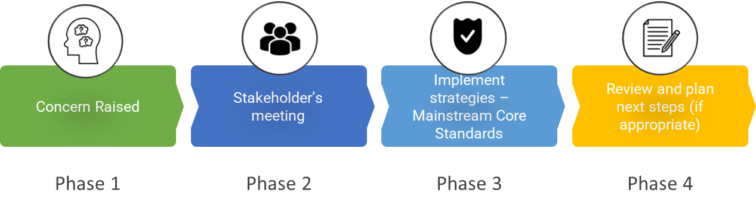

Phase 1 | If you think your child might have SEND, raise your concern with the school so that the SENDCO is aware.  You can speak directly with the class teacher, or SENDCO assistant, who can then arrange an appointment with the SENDCo. You can do this by contacting the school directly via the office or phoning and asking to speak with the SEND/Inclusion team. You can also email senadmin@htsj.school.
Phase 2 | We will meet with you to discuss your concerns and try to get a better understanding of what your child’s strengths and difficulties are. Together we will decide what outcomes to seek for your child and agree on next steps. We will make a note of what’s been discussed and add this to your child’s record.
Phase 3 | We will implement the agreed strategies and monitor these over an agreed period. These are likely to be universal strategies set out in the mainstream core standards. A copy of this can be found here: https://www.kelsi.org.uk/__data/assets/pdf_file/0005/117257/Special-educational-needs-mainstream-core-standards-guide-for-parents.pdf . This will initiate the ‘Graduated Approach’ where support will be continually reviewed. See next page for more details.
Phase 4 | If we decide that your child needs SEND support, we will notify you and your child will be added to the school’s SEND register. They will receive additional support, and this will be reviewed using the assess, plan, do, review model.

4. What happens if the school identifies a need?
All class teachers are responsible for monitoring the progress and development of all our pupils, including those who have been identified as having SEND.
If the teacher notices a pupil is having difficulties, they will adapt and plan support to fill any gaps in learning. The challenges pupils may experience could include difficulties in reading, writing, mathematics, communication, attention, organisation or relationships.
If the pupil is still finding it difficult to make the expected progress, the teacher will talk to the SENDCO and your child’s teacher or SENDCO will contact you to discuss the possibility that your child has SEND, and the school will follow the graduated approach.
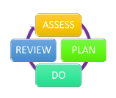
The chart below shows the process of what happens if there is a SEND need identified by the school that impacts on educational progress.

Difficulties identified  by school/home | ➜ | What can we do to  Support? | ➜ | What are our  next steps?
Class teacher and/or parents identify difficulties and they are discussed through:  Discussion between home and school  Class teacher asks SENDCO for advice  Child’s needs are discussed at Pupil Progress Meetings |  | High quality teaching and adaptive teaching  Class teacher adapts the Mainstream Core Standards according to need  Focus groups and targeted interventions  Review after an agreed amount of time – home and school  If successful continue to monitor closely and maintain successful strategies |  | If challenges continue despite additional support being put in place, the class teacher engages further with the SENDCO regarding further individualised strategies, interventions and support  Assessments to be completed to gain further understanding of strengths and barriers to learning, for example Speech and Language Link, Thrive assessments  A meeting with family and school to review provision. This may then lead to being placed on the SEND Register and referral to outside agencies for additional advice

5. How will the school measure my child’s progress?

We will follow the ‘graduated approach’ to meeting your child’s SEND needs, this approach is a 4 part cycle of assess, plan, do, review.
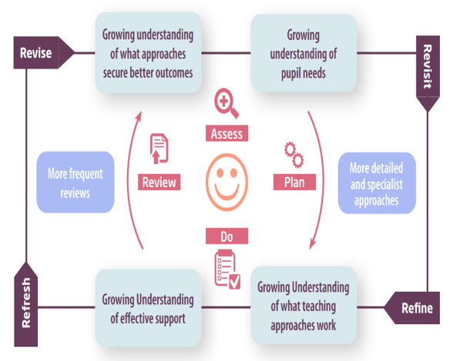
Assess | If your child is not making the expected level of progress, we will make an assessment to find out what strengths and difficulties your child has. We will ask for you and your child’s input, as well as getting help from external professionals where necessary.
Plan | In discussion with you and your child, we will decide what outcomes we are hoping to achieve. We will make a plan of the support we will offer your child to help them meet those outcomes. We will make a record of this and share it with you and all relevant school staff.
Do | We will put our plan into practice.  The class teacher, with the support of the SENDCO, will be responsible for working with your child on a daily basis, and making sure the support we put in place is having the impact we intended.
Review | We will assess how well the support we put in place helped the pupil to meet the outcomes we set. We will use our improved understanding of your child’s needs to improve the support we offer; this may mean the Assess, Plan, Do, Review cycle continues.

6. How will I be involved in decisions made about my child’s education?
We will provide 2 written reports on your child's progress throughout the year: a mid-year report in March and an annual report in July.
A member of staff who knows your child well will meet you 3 times a year, to:
- Set clear outcomes for your child’s progress
- Review progress towards those outcomes
- Discuss the support we will put in place to help your child make that progress
- Identify what we will do, what we will ask you to do, and what we will ask your child to do

The SENDCO may also attend these meetings to provide extra support.
We know that you’re the expert when it comes to your child’s needs and aspirations. So, we want to make sure you have a full understanding of how we’re trying to meet your child’s needs, so that you can provide insight into what you think would work best for your child.
We also want to hear from you as much as possible so that we can build a better picture of how the SEND support we are providing is impacting your child outside of school.
If your child’s needs or aspirations change at any time, please let us know right away so we can keep our provision as relevant as possible.
If you have concerns that arise between these meetings, please contact the class teacher, SENDCO Assistant or SENDCO. You can contact via the school office, by phone on 01843 223237 or via email senadmin@htsj.school to arrange an appointment.

7. How will my child be involved in decisions made about their education?
The level of involvement will depend on your child’s age and individual needs. We recognise that no two pupils are the same, so we will decide on a case by case basis, with your input.
We may seek your child’s views by asking them to:

- Attend meetings to discuss their progress and outcomes
- Prepare a presentation, written statement, video, drawing, etc.
- Discuss their views with a member of staff who can act as a representative during the meeting
- Complete a survey


8. How will the school adapt its teaching for my child?
Your child’s teachers are responsible and accountable for the progress and development of all the pupils in their class.
High-quality teaching is our first step in responding to your child’s needs. We will make sure that your child has access to a broad and balanced curriculum in every year they are at our school.
At Holy Trinity & St John’s CE Primary School, we are guided by the Mainstream Core Standards https://www.kent.gov.uk/about-the-council/strategies-and-policies/service-specific-policies/education-policies/send-strategies-and-policies/send-mainstream-core-standards on how to adapt the curriculum and learning environment for pupils with special educational needs. We also draw on information from both internal and external assessments, alongside strategies identified in personalised plans and provision maps.
We tailor our approach to each pupil’s individual needs, strengths and preferred ways of learning. There is no “one size fits all” approach; teaching, support and adaptations are carefully planned to ensure they are meaningful and effective for your child.

These adaptations may include:
      - Adapting our approaches, for example, giving longer processing times, pre-teaching of key vocabulary, reading instructions aloud, etc.

      - Adapting our resources and staffing

      - Sharing learning objectives with the children during lessons

      - Assessment for Learning to ensure pitch and pace of lessons is appropriate

      - Using recommended aids, such as laptops, coloured overlays, visual timetables, larger font, etc.


      - Teaching assistants or support staff will support pupils appropriately depending on their presentation of need, under class teacher direction

      - Groups are varied to ensure that all children have access to the class teacher and TA


      - Scaffolding lesson materials

      - All work is marked following the school marking policy


      - Celebrating work of all children within the classroom and throughout the school

      - Alternative ways of recording are used, where appropriate

      - Where appropriate, individual personalised plans are used to identify personal support targets.
      - A pupil may receive additional adult support individually or in a small group, with the aim of developing independence through appropriate support, encouragement and gradually reduced prompts.

      - Involvement of outside agencies to support individual need as appropriate e.g. speech and language
We may also provide the following interventions:
- Precision Teaching
- Little Wandle Phonics
- First Class at Number
- Daily 1:1 reading
- Social skills groups
- Social, emotional and mental health intervention such as Think Good, Feel Good and ELSA
- Sensory Circuits
- FIZZY
- Clever Hands
- Thrive
- Speech and Language – 1:1 or small group sessions
- Nurture pathway
- Attention Bucket
- Intensive Interaction

These interventions are part of our contribution to Kent County Council’s local offer.

9. How will the school evaluate whether the support in place is helping my child?
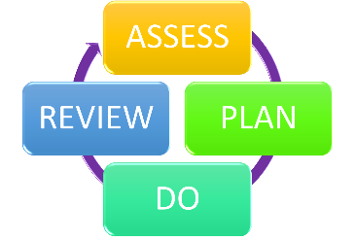
We will evaluate the effectiveness of provision for your child by:
- Reviewing their progress towards their goals each term
- Reviewing the impact of interventions at appropriate intervals, as guided by the programme.
- Using pupil questionnaires and collecting pupil voice
- Monitoring by the SENDCO and wider Senior Leadership Team
- Using class provision maps, pupil passport and individual education plans to measure progress
- Holding an annual review (if they have an education, health and care (EHC) plan)

10. How will the school ensure my child has appropriate resources?
It may be that your child’s needs mean we need to provide additional resources such as:
- Additional resources to support their learning
- Adaptations to in class support
- Further training for our staff
- External specialist expertise
Where appropriate, we will consult with external agencies to get recommendations on what will best help your child access their learning and use our best endeavours to ensure these are supplied.
As part of our budget, we receive ‘notional SEN funding’. This funding is used to ensure that the quality of teaching is good in the school and to provide additional and different provision for pupils requiring SEND support. The amount of support required for each pupil to make good progress will be different in each case and designed to meet the pupil’s needs.
We have recently received funding from the Department of Education, this funding is to be used to for continuing to strengthen inclusion within our school, a statement detailing how we have used this fund to continue to enhance our inclusive practices will be on our website from December 2026.

11. How will the school make sure my child is included in activities alongside pupils who don’t have SEND?


All our extra-curricular activities and school visits are available to all our pupils. All clubs, trips and activities are offered to pupils at Holy Trinity & St John’s and are available to pupils with special educational needs either with or without an Education, Health and Care Plan. Where it is necessary, the school will use the resources available to it to provide additional adult support to enable the safe participation of the pupil in the activity. It is also our practice to adapt environment and equipment when and where necessary to ensure equal access and successful participation. No pupil is ever excluded from taking part in these activities because of their SEND and we will make whatever reasonable adjustments are needed to be made to make sure that they can be included which may include being supported by parents or carers.

12. How does the school make sure the admissions process is fair for pupils with SEN or a disability?


- Before the application of oversubscription criteria, children with an Education, Health and Care Plan (EHCP), which names the school will be admitted. As a result of this, the Published Admissions Number will be reduced accordingly.
- If the number of preferences for the school is more than the number of spaces available, places will be allocated to Looked After Children and previously Looked After Children first.
- Our admissions arrangements do not unfairly disadvantage children with SEND or disabilities. Further information about our admissions arrangements can be found on our website. https://www.holytrinitymargate.co.uk/school-admissions/

13. How does the school support pupils with disabilities?


You’re disabled under the Equality Act 2010 if you have a physical or mental impairment that has a ‘substantial’ and ‘long-term’ negative effect on your ability to do normal daily activities.
Holy Trinity & St John’s CE Primary School is committed to providing an environment that enables full curriculum access that values and includes all pupils, staff, parents and visitors regardless of their education, physical, sensory, social, spiritual, emotional and cultural needs. We are committed to taking positive action in the spirit of the Equality Act 2010 regarding disability and to developing a culture of inclusion, support and awareness within the school. As and where necessary, if an area of the school is identified as in need of improvement, it will be the school’s best endeavour to improve this either through building and maintenance improvements; or by staff training. This will be outlined in our Accessibility Plan. NEED LINK
The steps taken to prevent disabled pupils from being treated less favourably than other pupils are:
- Children will have access to tools that support self-regulation so that they understand when and how to be ready to learn
- Children can have access to low tech solutions to support access to learning (Such as Clicker 8, Communicate in Print, iPad, laptops).
- The Specialist Resource Provision ensures children’s needs are well met and they are having full access to a rich and varied curriculum
- Accessibility is incorporated into all new building developments in school, and the current accommodations are well maintained – such as the accessible toilets and lift

14. How will the school support my child’s mental health and emotional and social development?
Holy Trinity & St John’s CE Primary School is a school built on love, where leaders lead with compassion and positive relationships are at the heart of everything we do. We foster a love of learning for all as we recognise that in doing so, we lay the foundations for achievement and for our children to leave us the most successful version of themselves.
As a church school, we nurture a strong sense of moral purpose to support us to care and serve one another and contribute positively to our community. We understand that an important element of the school is to enable all pupils to develop emotional resilience and social skills they need to thrive, both in school and beyond. We promote a culture of kindness, respect and belonging, where bullying is not tolerated and every child is supported to feel safe, valued and included.
We develop these skills both through direct teaching, for example, via Personal, Social and Health Education (PSHE), Religious Education (RE), Woodland School, our extensive extra-curricular programme, teaching and modelling metacognition and strategies, Zones of Regulation and The Colour Monster Curriculum and indirectly with every conversation adults have with pupils throughout the day.
This starts from the moment children join HTSJ with emotional resilience forming a large part of the child-initiated learning in reception class. Teachers, teaching assistants and all support staff have all been trained in restorative approaches to support children’s social, emotional and mental health needs, being available to be a co-regulator when children need.
We provide support for pupils to progress in their emotional and social development in the following ways:
- Pupils with SEND are encouraged to be part of the school council and have class and whole school responsibilities
- We provide extra pastoral support for listening to the views of all pupils.
- There are accessible sensory tools available in all classes to help support regulation.
- Sensory spaces are available within the school for those children who have more complex needs.
- We have a pastoral lead and Thrive champions across the school to give additional support to the children.

15. What support is in place for looked-after and previously looked-after children with SEND?


Mrs Roberts is the designated teacher for looked-after children and previously looked-after children.
Mrs Roberts will work with Mrs McGuirk, our SENDCO, to make sure that all teachers understand how a looked-after or previously looked-after pupil’s circumstances and their SEND might interact, and what the implications are for teaching and learning.
Pupils who are looked-after or previously looked-after will be supported much in the same way as any other child who has SEND. However, looked-after pupils will also have a personal education plan (PEP). We will make sure that the PEP and pupil passport, individual education plans or EHC plans are consistent and complement one another.
Mrs Roberts can be contacted through the school office - office@htsj.school

16. What support will be available for my child as they transition between classes or settings or in preparing for adulthood?
When moving to a new school, Holy Trinity & St John’s CE Primary will ensure that they can provide a smooth transition. This includes informing the new school of current achievements, support that was in place and any other important information specific to the child. This is also the case for any child joining us from another school, in these instances HTSJ will endeavour to gather as much information from the previous school as possible.
The SENDCO will attend a transfer day, meeting with the SENDCOs of local nurseries and secondary schools to pass on information about the children moving to us in Reception or to their secondary school at the end of Year 6. When more support is needed this is discussed in consultation with parent/carers to determine a plan of provision and support according to the child’s needs.
Between years

To help pupils with SEND be prepared for a new school year we:
- Ask both the current teacher and the next year’s teacher to attend final meetings of the year when the pupil’s SEND is discussed
- Schedule lessons with the incoming teacher towards the end of the summer term
Between schools
When your child is moving on from our school, we will ask you and your child what information you want us to share with the new setting.
Primary to secondary transition
The SENDCO of the secondary school will come into our school for a meeting with our SENDCO. They will discuss the needs of all the pupils who are receiving SEND support.

Pupils will be prepared for the transition by:
- Learning how to get organised independently
- Having lessons taught by more than their class teacher
- Attend transition meetings
- Attend additional transition sessions

17. What support is available for me and my family?
If you have questions about SEND, or are struggling to cope, please get in touch to let us know. We want to support you, your child and your family.
To see what support is available to you locally, have a look Kent’s Local offer, which is referred to as the SEND Information Hub. Kent publishes information about the local offer on their website:
https://www.kent.gov.uk/education-and-children/special-educational-needs
Our local special educational needs and disabilities information advice and support services (SENDIASS) organisations are:
https://www.iask.org.uk/
Helpline: 03000413000
Email: iask@kent.gov.uk
National charities that offer information and support to families of pupils with SEND are:
- IPSEA
- SEND family support
- NSPCC
- Family Action
- Special Needs Jungle

18. What should I do if I have a complaint about my child’s SEND support?
https://www.holytrinitymargate.co.uk/policies/
The normal arrangements for the treatment of complaints at Holy Trinity & St John’s CE Primary School are used for complaints about provision made for special educational needs. We encourage parents to discuss their concerns with the class teacher, SENDCO, Assistant Headteachers or the Headteacher to resolve the issue before making the complaint formal to the Chair of the Governing Body.
If you are not satisfied with the school’s response, you may escalate the complaint.
In some circumstances, this right also applies to the pupils.

Please refer to our Complaints Procedure for further information.

To see a full explanation of suitable avenues for complaint, see pages 246 and 247 of the SEND Code of Practice.
If you feel that our school discriminated against your child because of their SEND, you have the right to make a discrimination claim to the first-tier SEND tribunal. To find out how to make such a claim, you should visit: https://www.gov.uk/complain-about-school/disability-discrimination
You can make a claim about alleged discrimination regarding:
- Admission
- Exclusion
- Provision of education and associated services
- Making reasonable adjustments, including the provision of auxiliary aids and services
- Before going to a SEND tribunal, you can go through processes called disagreement resolution or mediation, where you try to resolve your disagreement before it reaches the tribunal.
There are some circumstances, usually for children who have an EHCP, where there is a statutory right for parents to appeal against a decision of the Local Authority. Complaints which fall within this category cannot be investigated by the school.

19. Supporting documents

- https://www.holytrinitymargate.co.uk/policies/
- Equality statement and objectives
- Child protection policy
- Relational approach to behaviour Policy
- Accessibility Plan and policy
- Attendance policy
- SEND policy
- SEN & Disabilities Code of Practice 2015
- Mainstream Core Standards

20. Glossary
- Access arrangements – special arrangements to allow pupils with SEND to access assessments or exams
- Annual review – an annual meeting to review the provision in a pupil’s EHC plan
- Area of need – the 4 areas of need describe different types of needs a pupil with SEND can have. The 4 areas are communication and interaction; cognition and learning; physical and/or sensory; and social, emotional and mental health needs.
- CAMHS – child and adolescent mental health services
- Differentiation – when teachers adapt how they teach in response to a pupil’s needs
- EHC needs assessment – the needs assessment is the first step on the way to securing an EHC plan. The local authority will do an assessment to decide whether a child needs an EHC plan.
- EHC plan – an education, health and care plan is a legally-binding document that sets out a child’s needs and the provision that will be put in place to meet their needs.
- First-tier tribunal/SEND tribunal – a court where you can appeal against the local authority’s decisions about EHC needs assessments or plans and against discrimination by a school or local authority due to SEND
- Graduated approach – an approach to providing SEND support in which the school provides support in successive cycles of assessing the pupil’s needs, planning the provision, implementing the plan, and reviewing the impact of the action on the pupil
- Intervention – a short-term, targeted approach to teaching a pupil with a specific outcome in mind
- Local offer – information provided by the local authority which explains what services and support are on offer for pupils with SEND in the local area
- Outcome – target for improvement for pupils with SEND. These targets don't necessarily have to be related to academic attainment
- Reasonable adjustments – changes that the school must make to remove or reduce any disadvantages caused by a child’s disability
- SENDCO – the special educational needs and disabilities co-ordinator
- SEN – special educational needs
- SEND – special educational needs and disabilities
- SEND Code of Practice – the statutory guidance that schools must follow to support pupils with SEND
- SEND information report – a report that schools must publish on their website, that explains how the school supports pupils with SEND
- SEND support – special educational provision which meets the needs of pupils with SEND
- Transition – when a pupil moves between years, phases, schools or institutions or life stages

